ภาคผนวก ก
UML ของระบบทะเบียนนักศึกษาระดับบัณฑิตศึกษา

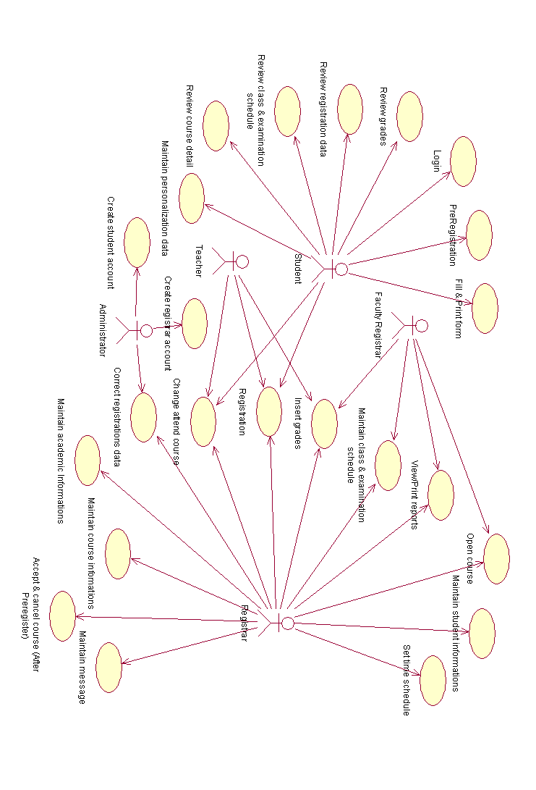
Usecase Diagram

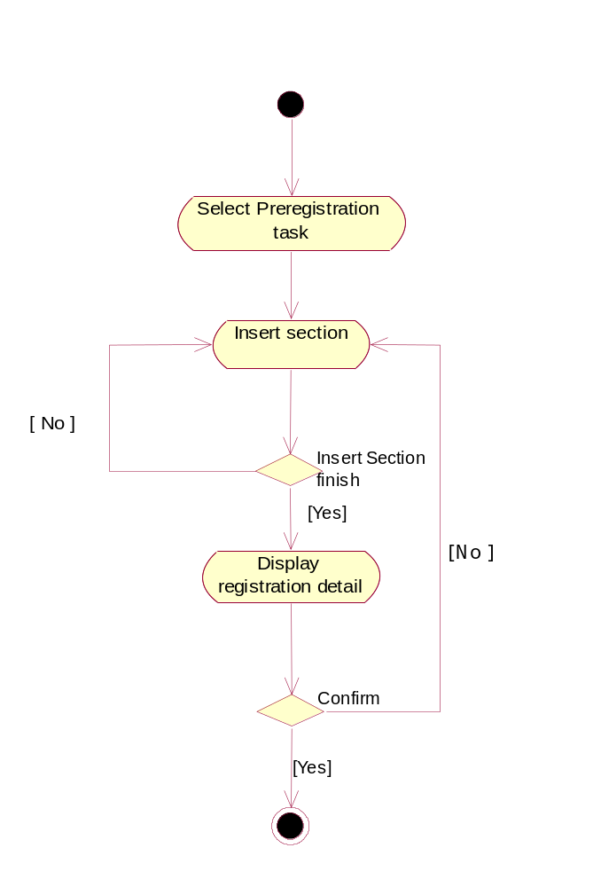
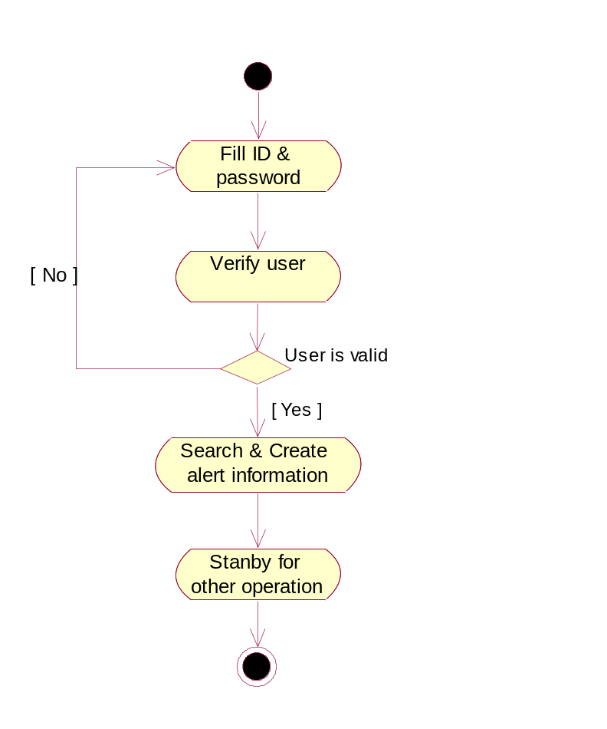

Activity Diagram / Login

Activity Diagram /Preregistration

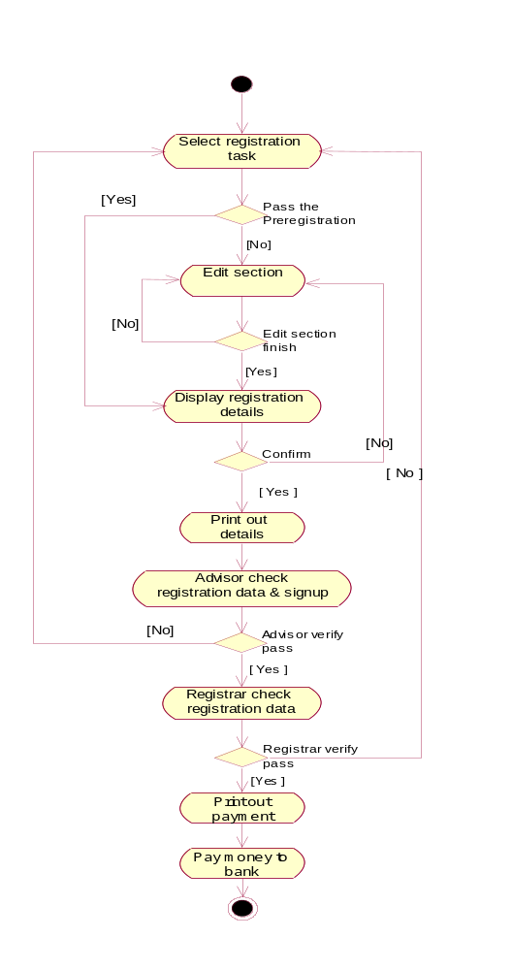

Activity Diagram / Registration

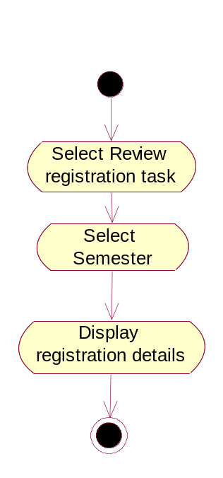

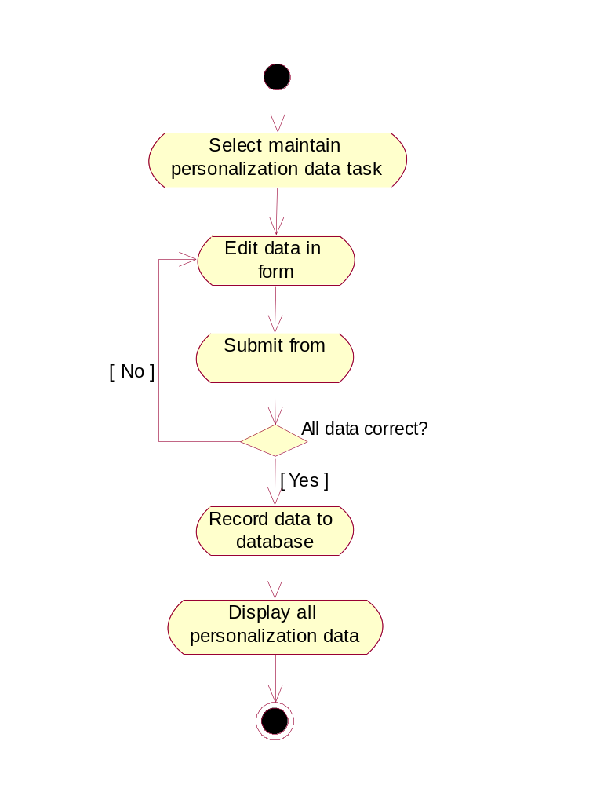

Activity Diagram / Review Registration

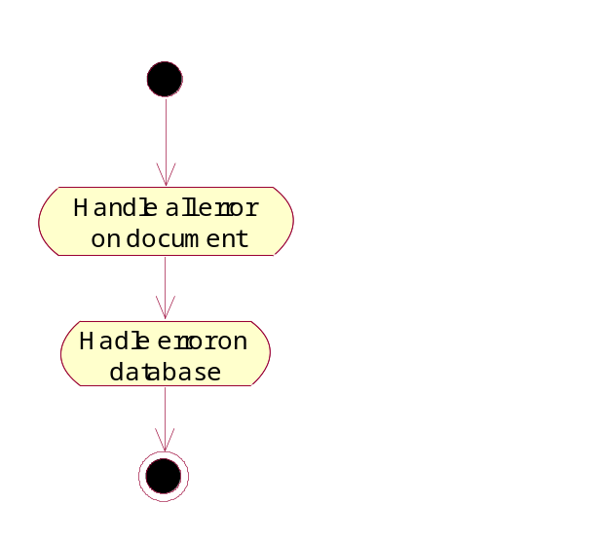

Activity Diagram /Maintain personalization data

Activity Diagram /Correct registrations data

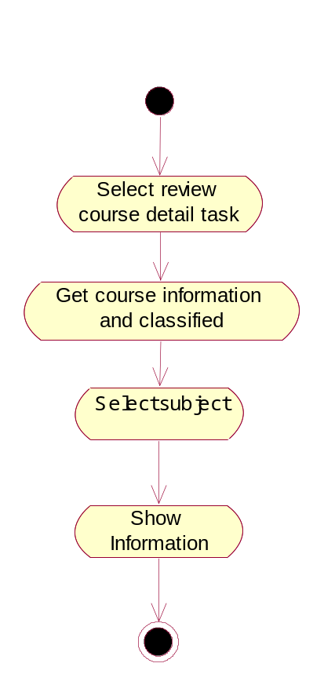
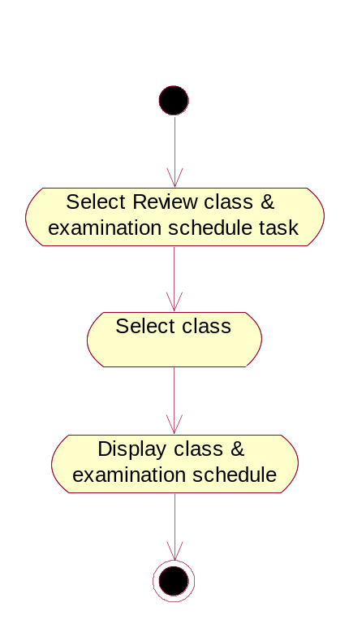

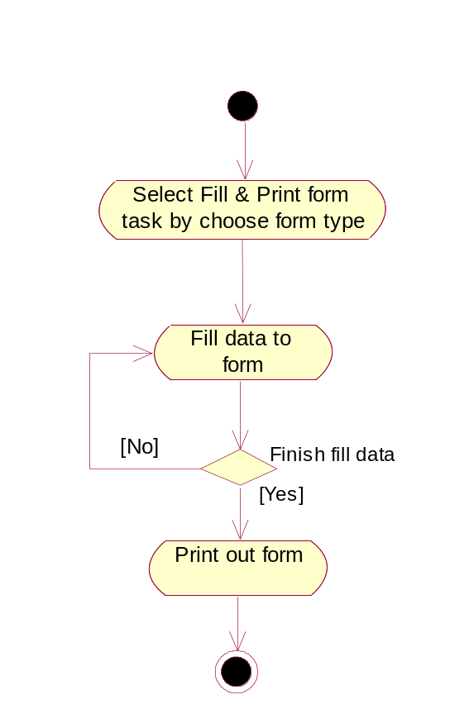
Activity Diagram / Review class & examination schedule

Activity Diagram / Review Course Detail

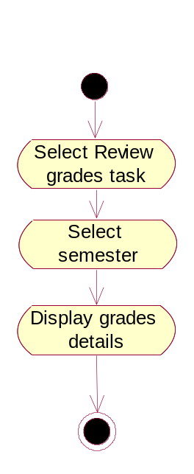

Activity Diagram / Fill & Print Form
Activity Diagram / Review Grades

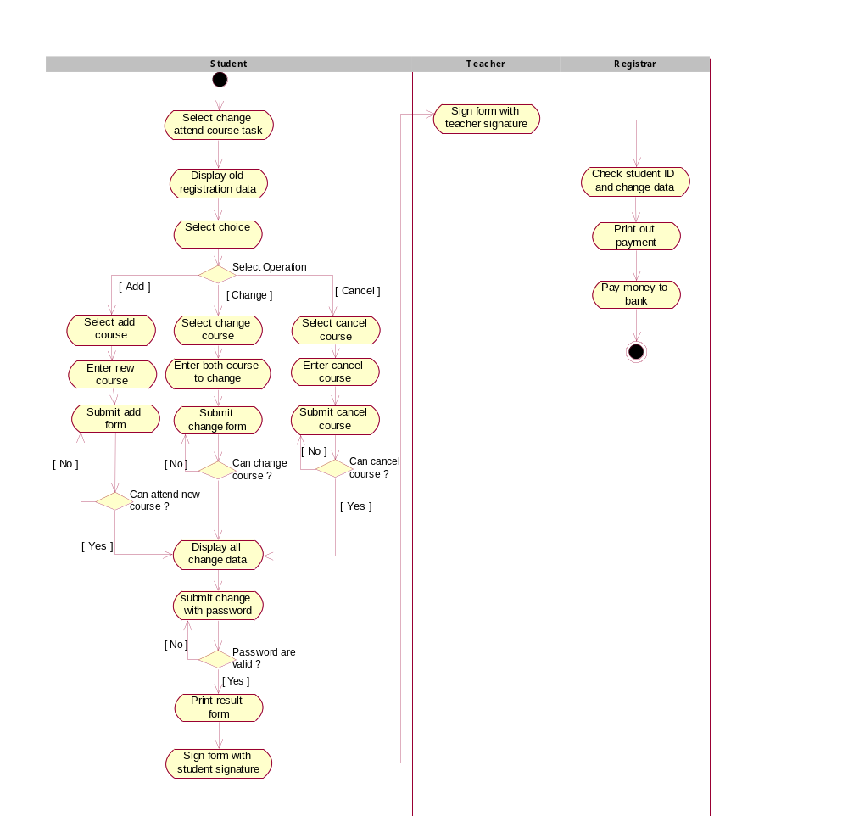

Activity Diagram / Chang Attend Course

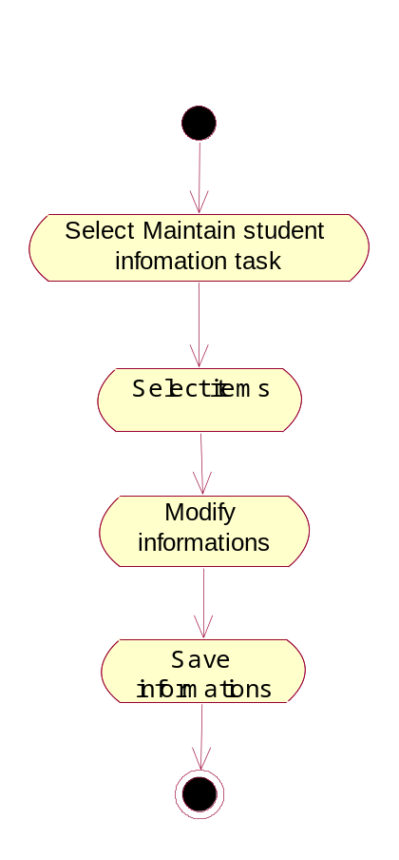

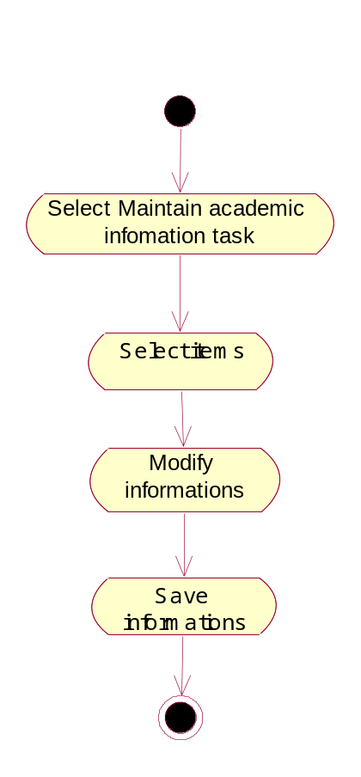

Activity Diagram / Maintain Student Information

Activity Diagram / Maintain Academic information

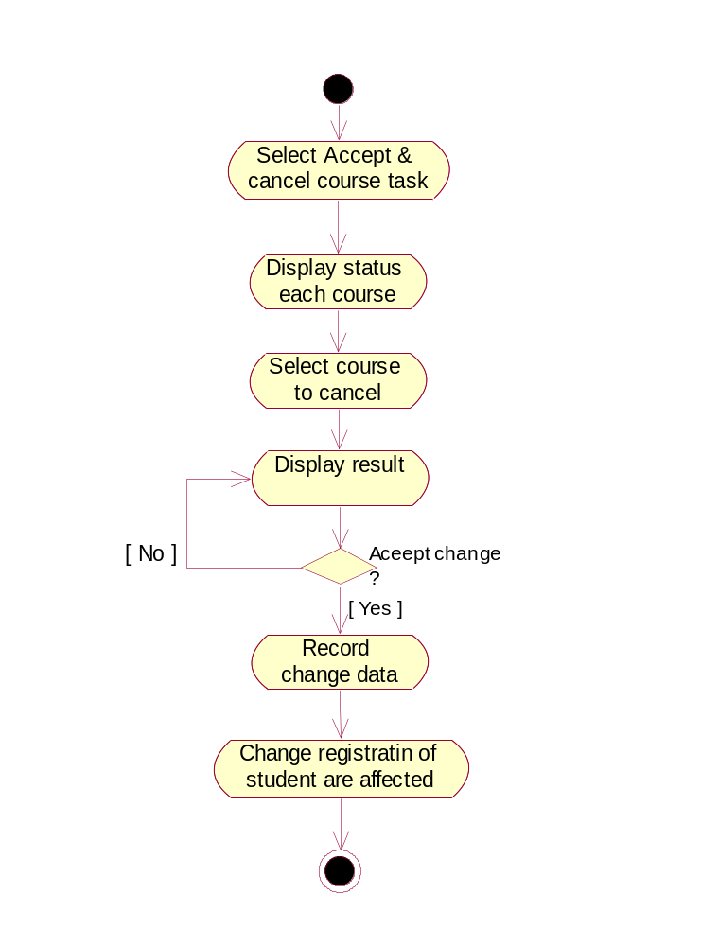

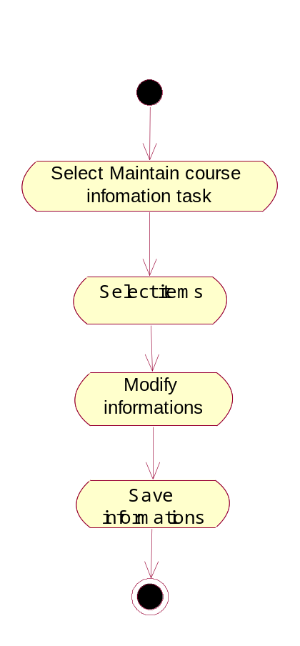

Activity Diagram / Maintain Course Information

Activity Diagram / Accept & Cancel Course

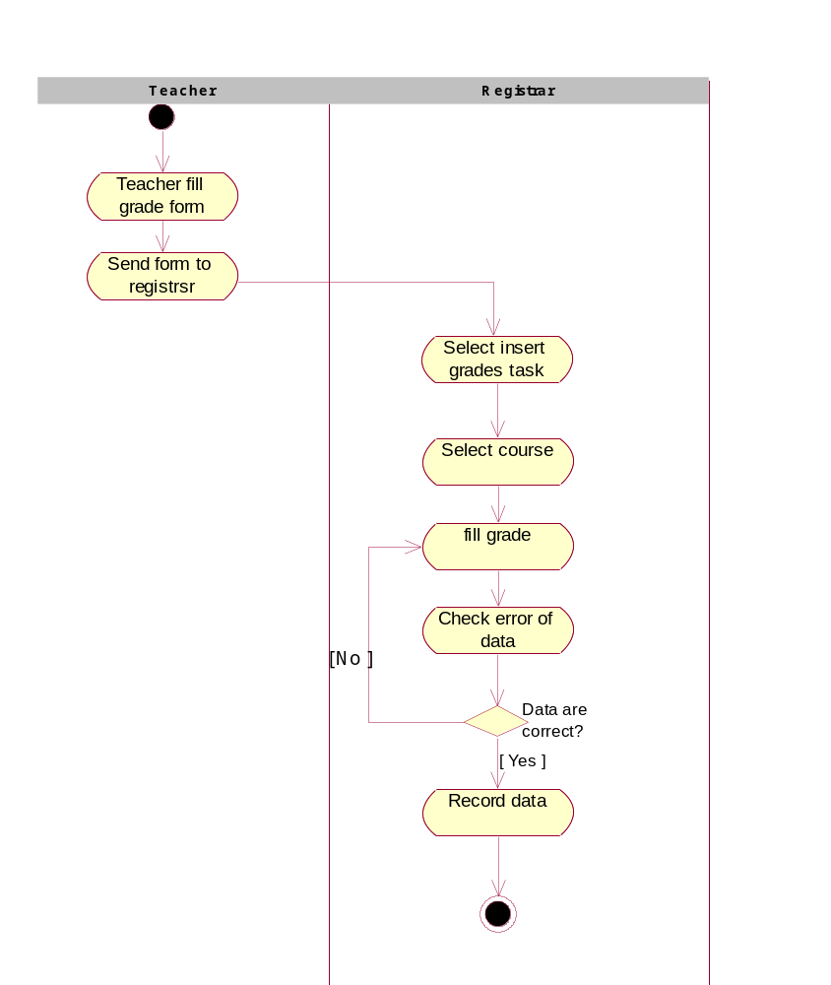

Activity Diagram / Insert Grade

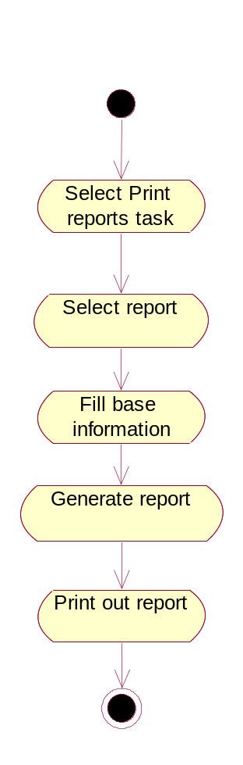
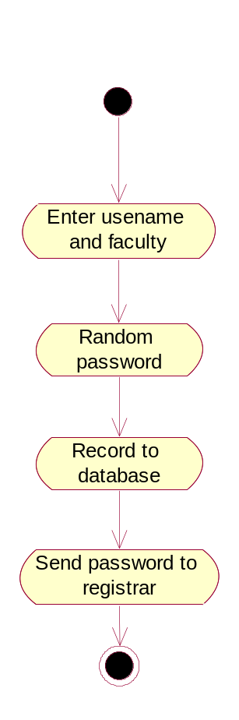

Activity Diagram / View & Print Report
Activity Diagram / Create registrar account

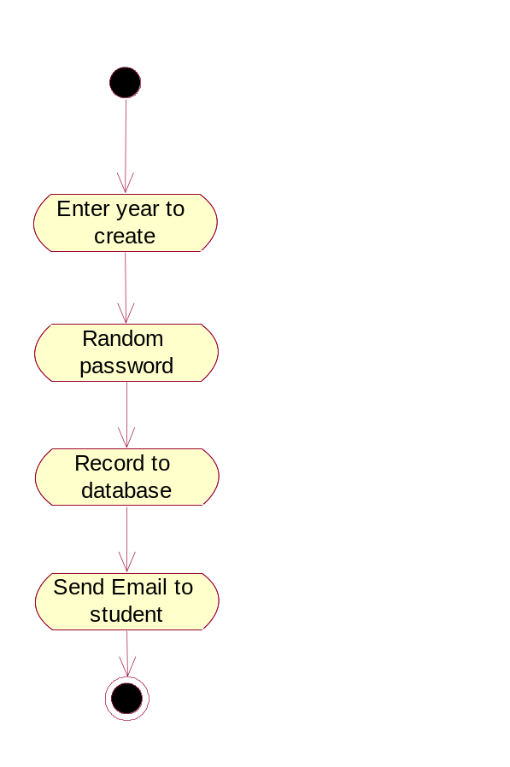
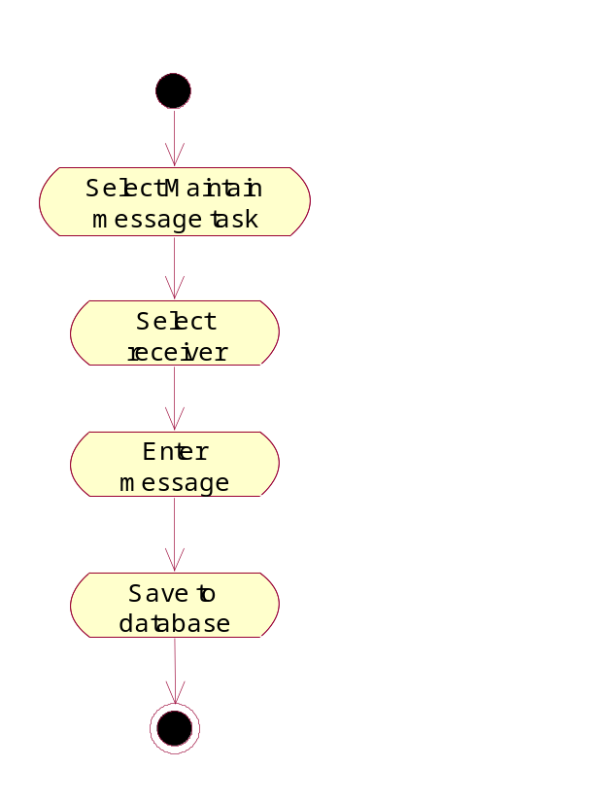

Activity Diagram / Create Student account
Activity Diagram / Maintain Message

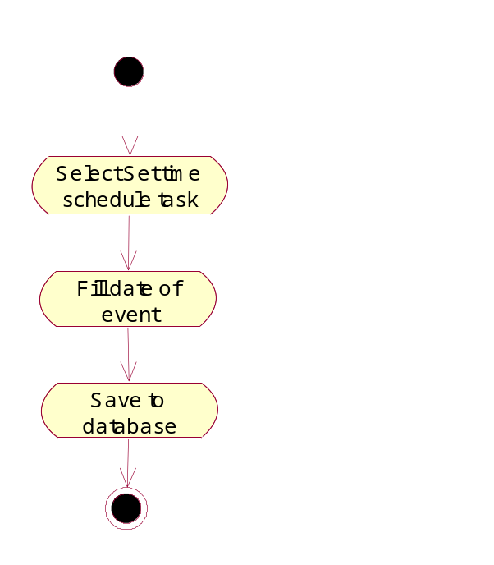

Activity Diagram /Set Time

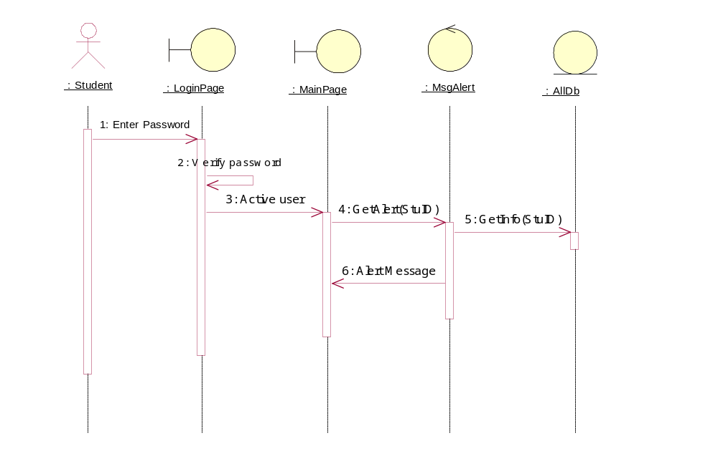

Sequence Diagram/Login

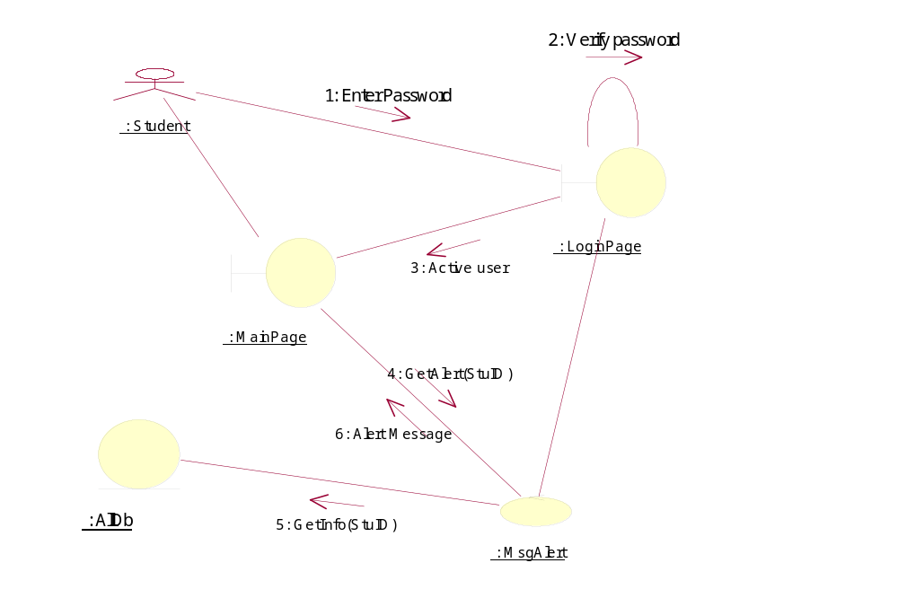

Collaboration Diagram/Login

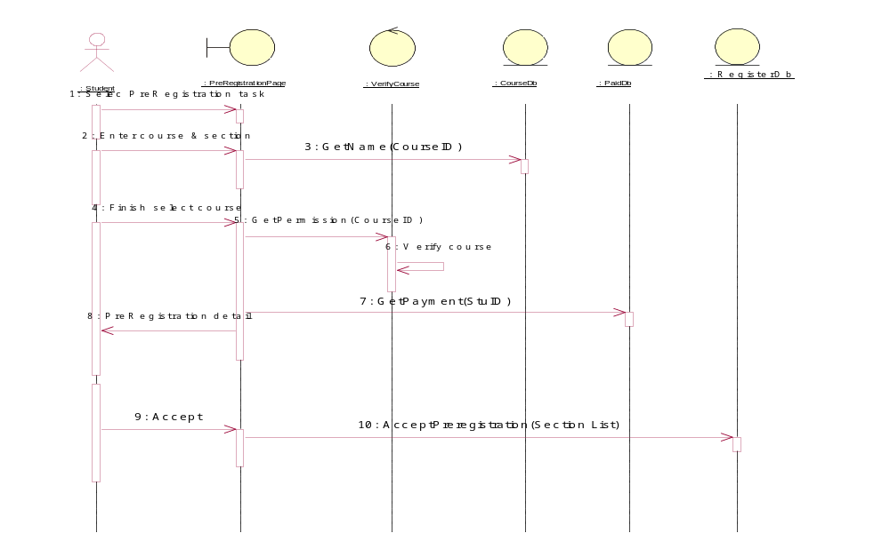
Sequence Diagram/PreRegister
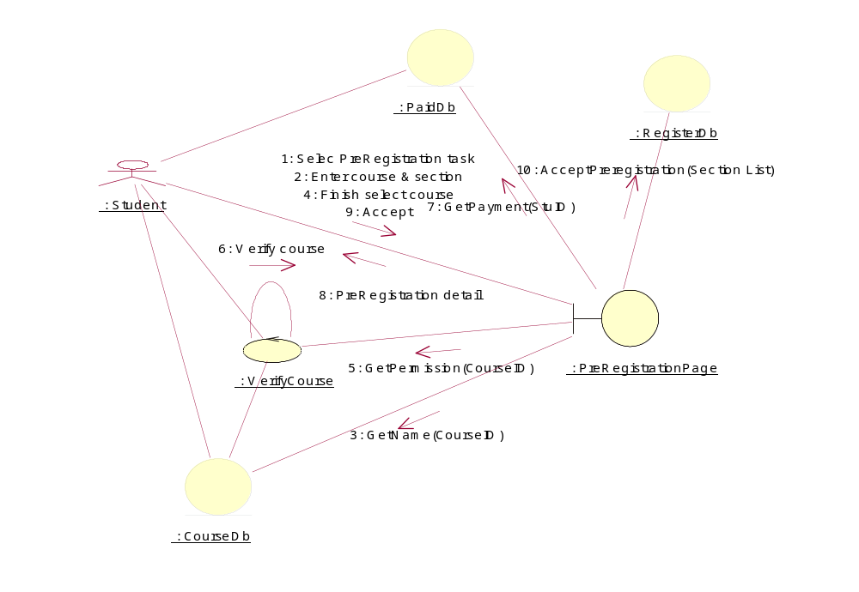

Collaboration Diagram/PreRegister
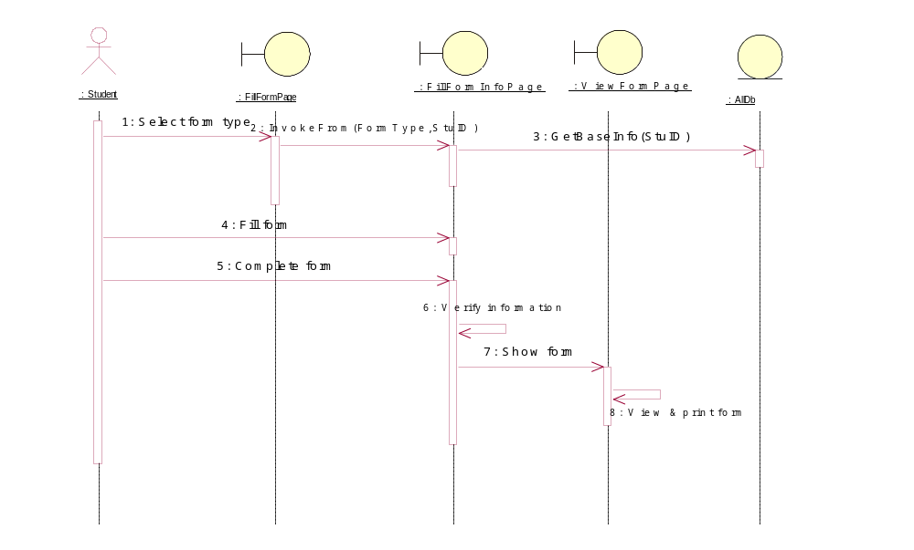
Sequence Diagram/Fill & print form

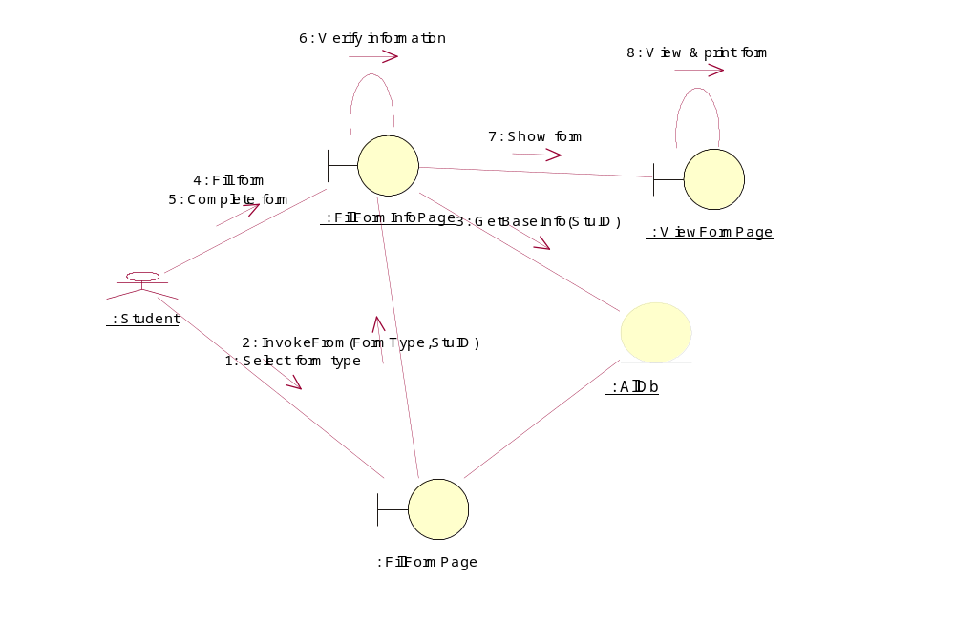

Collaboration Diagram/Fill & print form

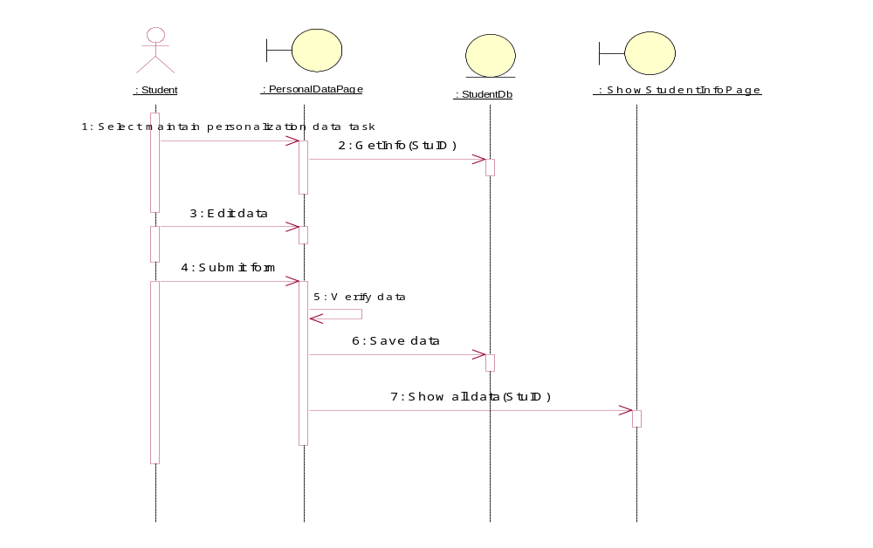

Sequence Diagram/Maintain personalization data

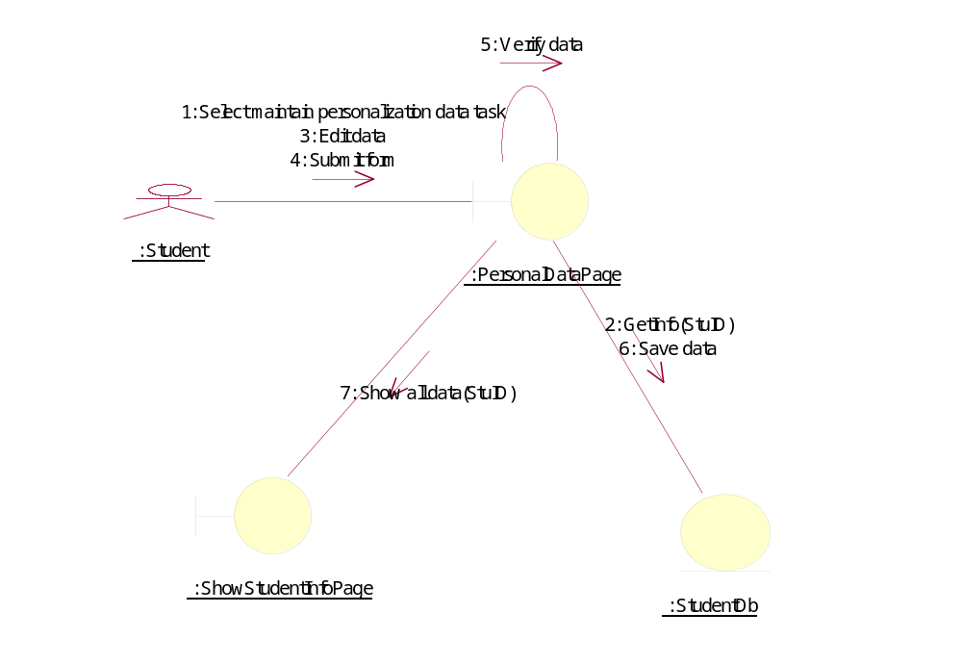

Collaboration Diagram/Maintain personalization data
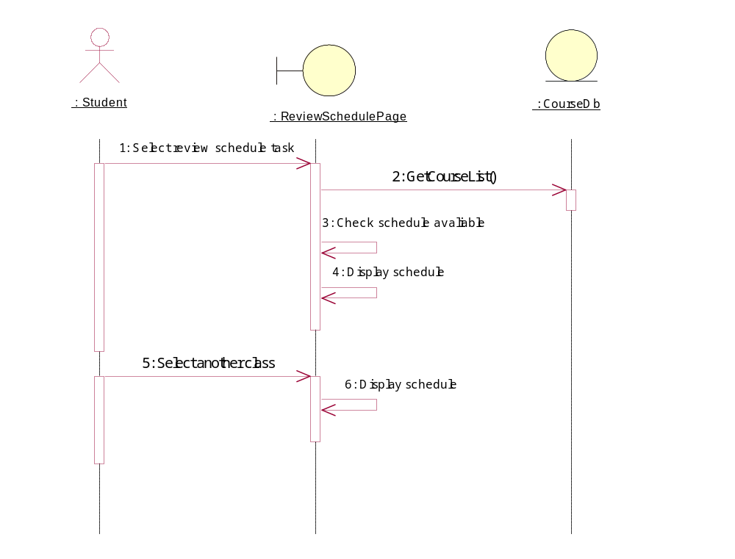

Sequence Diagram/Review class & examination schedule

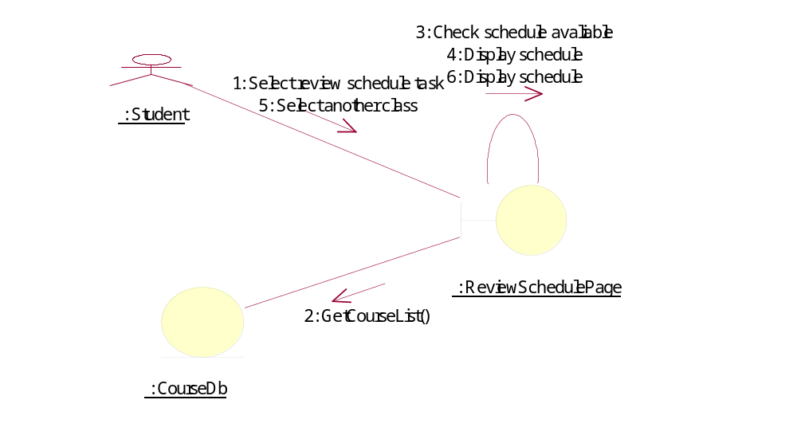
Collaboration Diagram/Review class & examination schedule

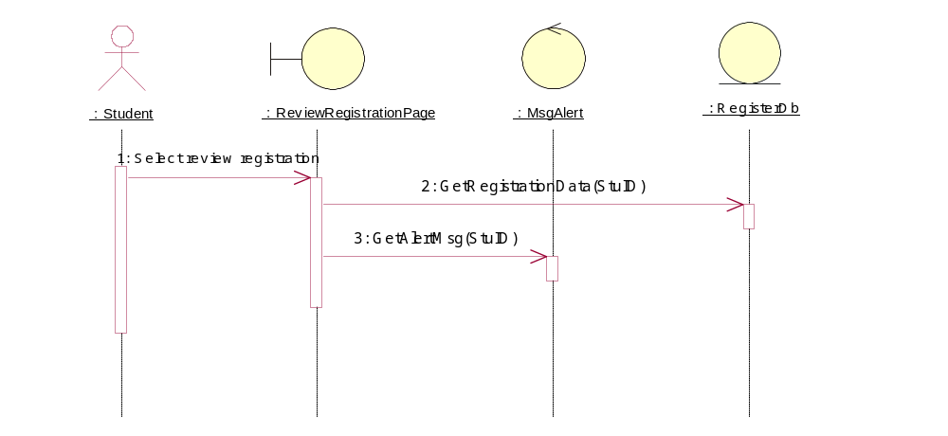

Sequence Diagram/Review registation

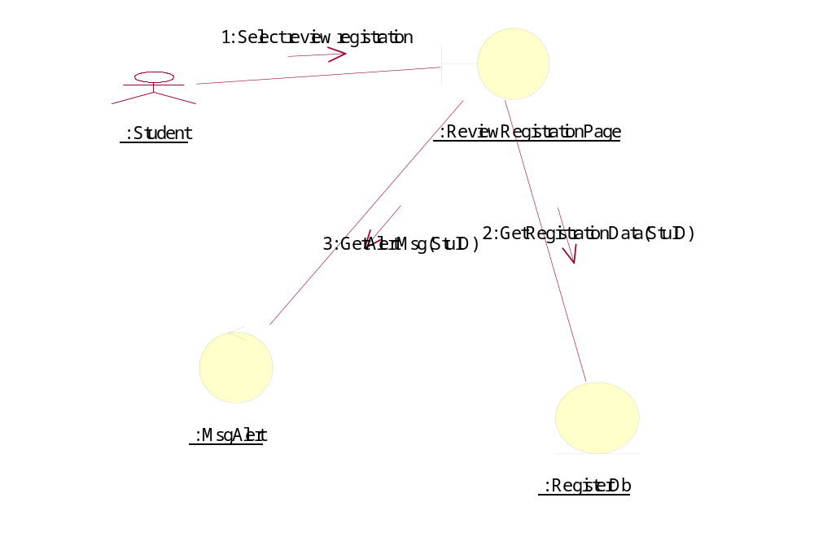

Collaboration Diagram/Review registation

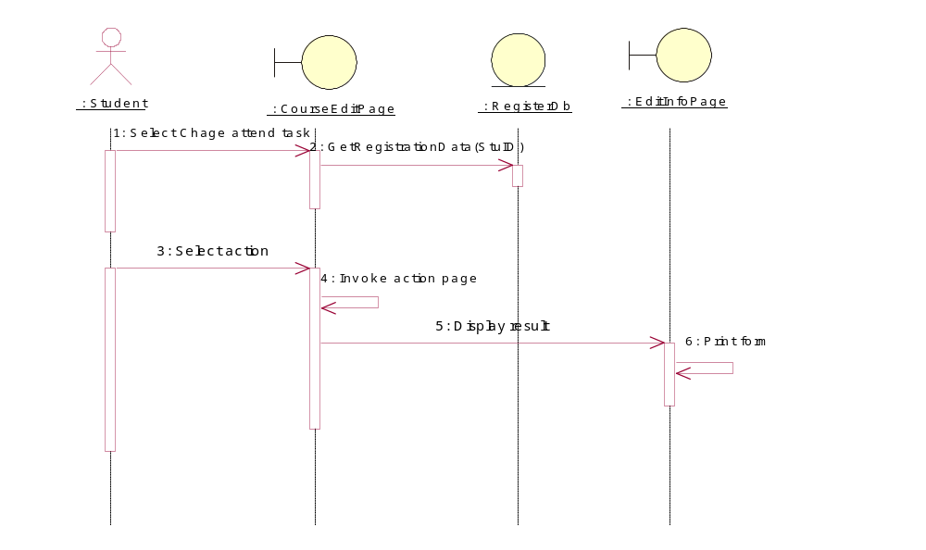

Sequence Diagram/StudentChange

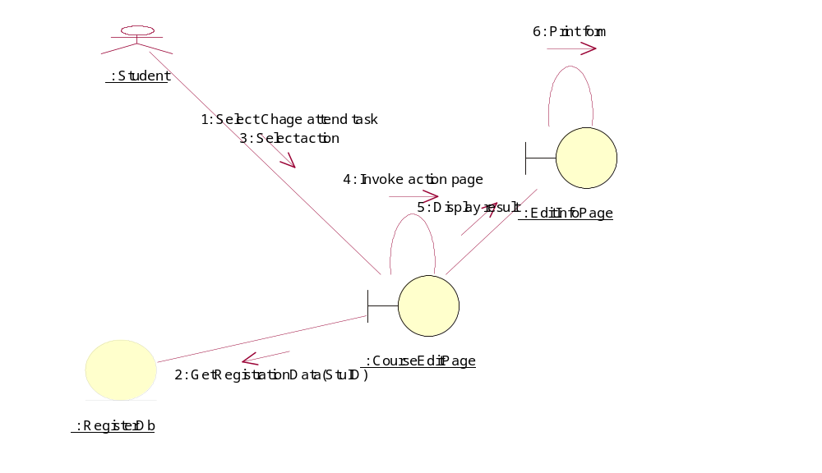

Collaboration Diagram/StudentChange
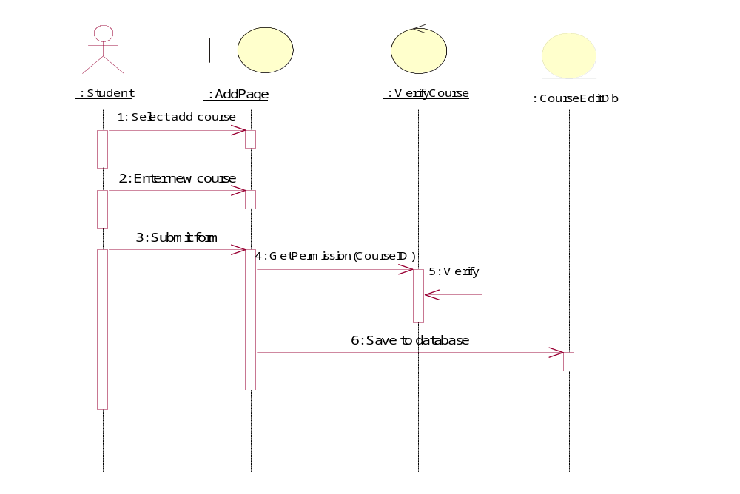
Sequence Diagram/AddCourse

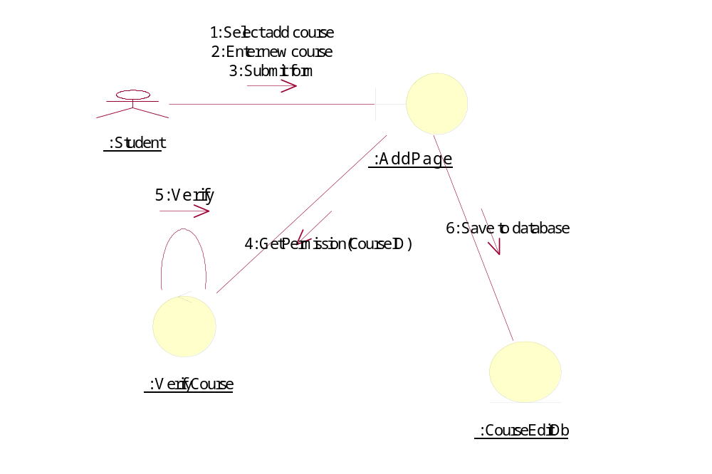

Collaboration Diagram/AddCourse
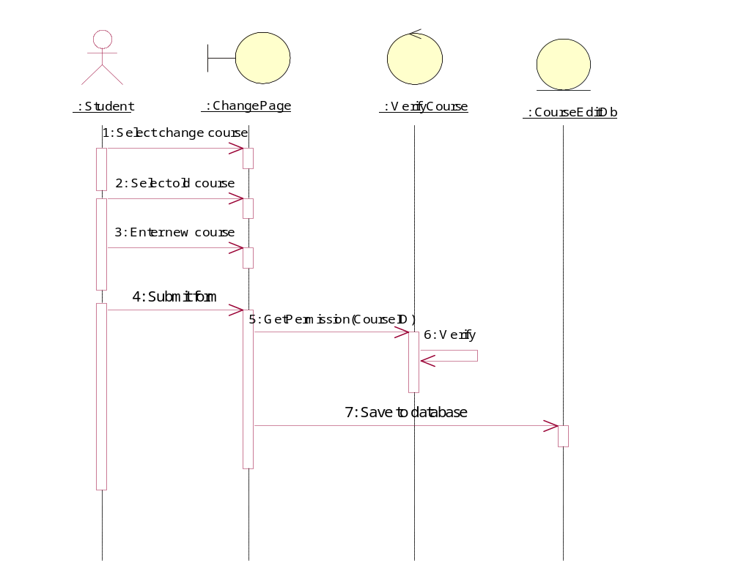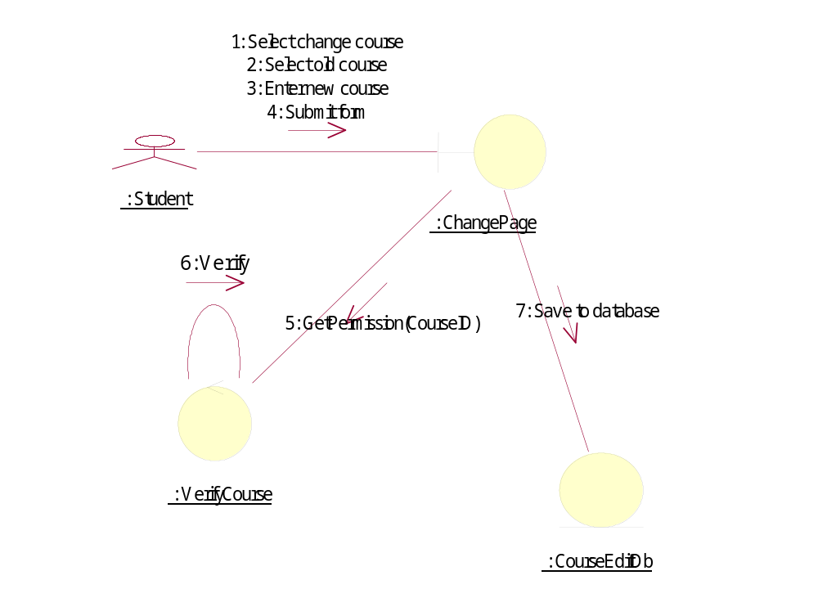

Sequence Diagram/ChangeCourse

Collaboration Diagram/ChangeCourse
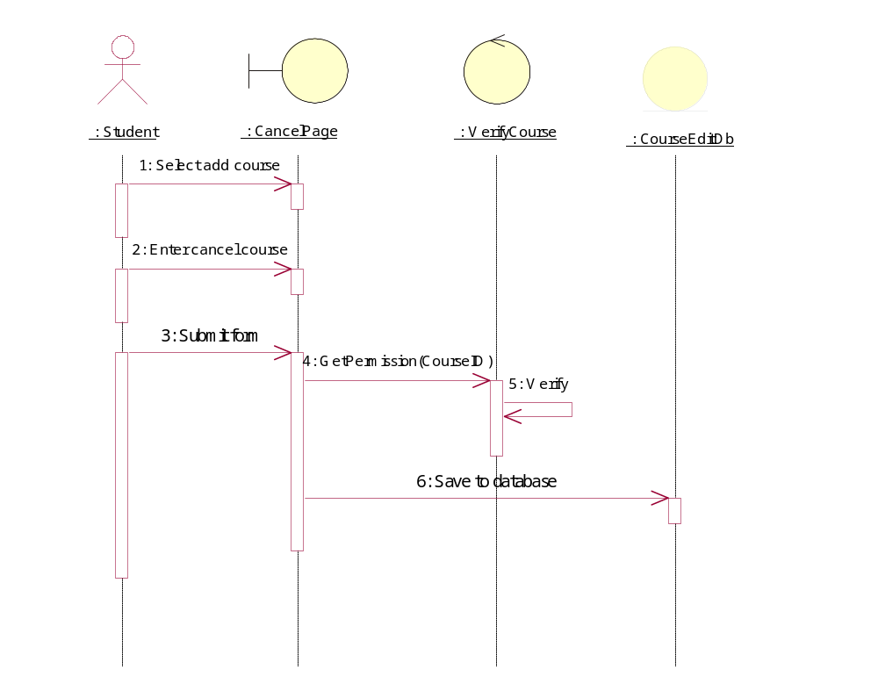
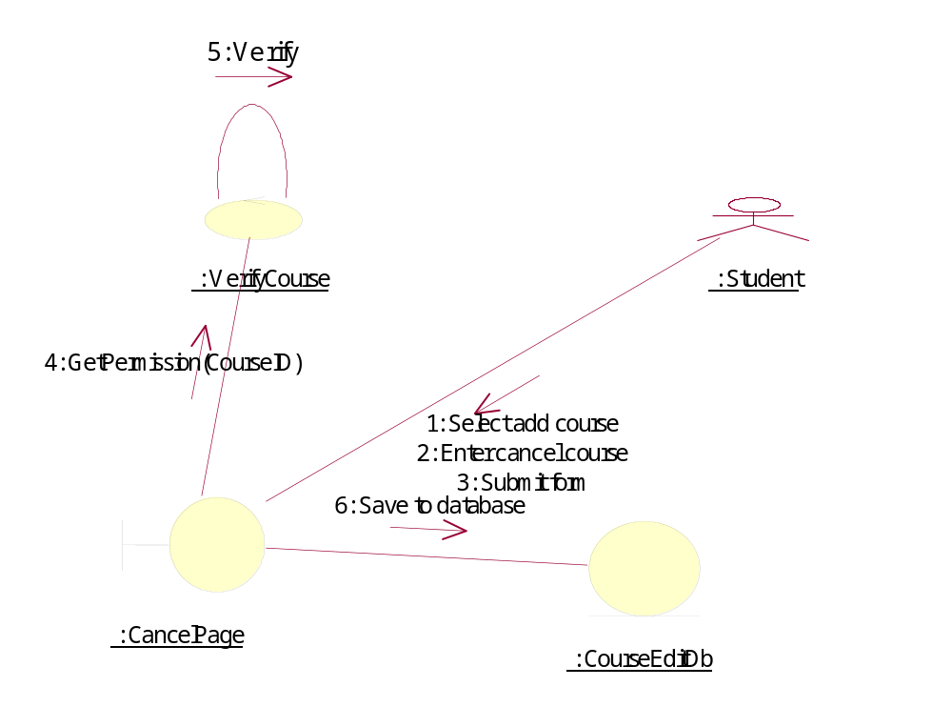

Sequence Diagram/CancelCourse
Collaboration Diagram/CancelCourse
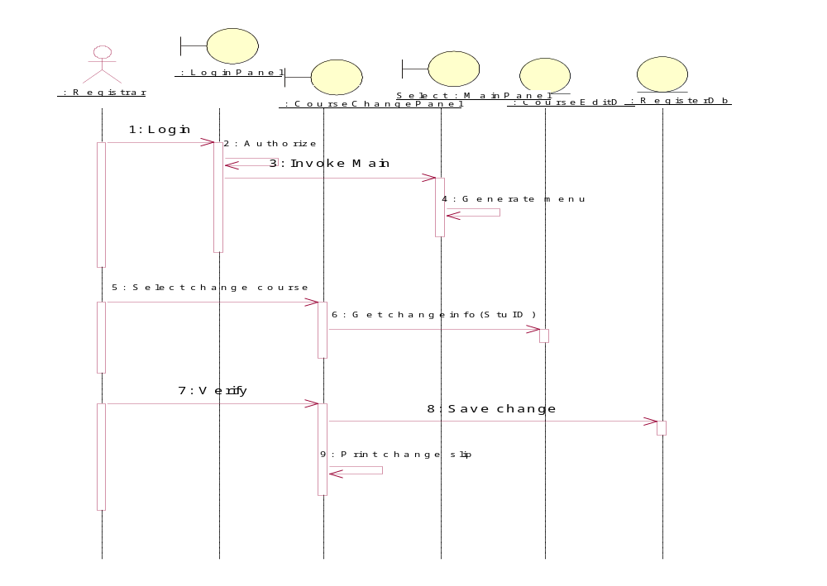
Sequence Diagram/AcceptChange

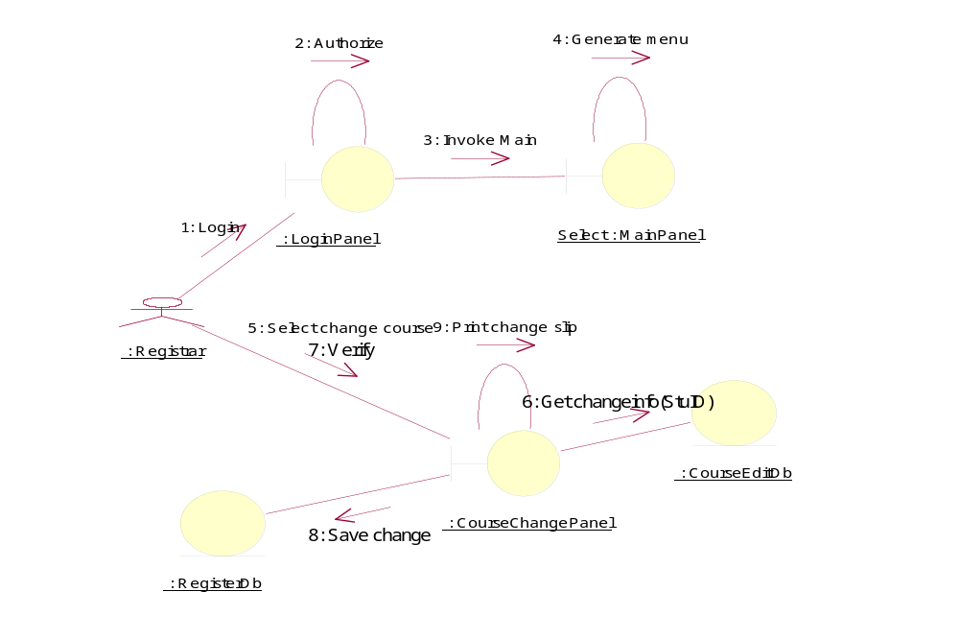

Collaboration Diagram/AcceptChange

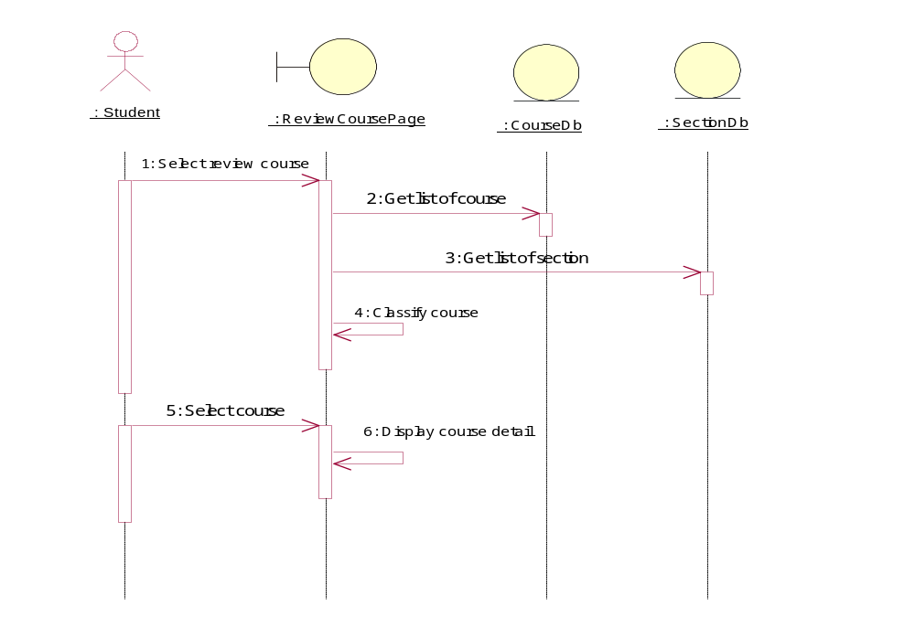

Sequence Diagram/Review course

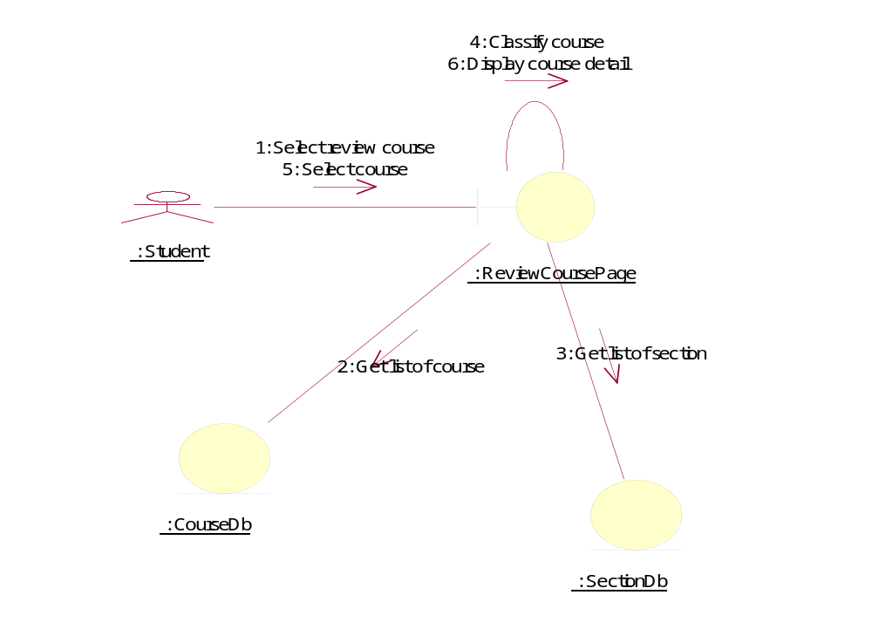

Collaboration Diagram/Review course
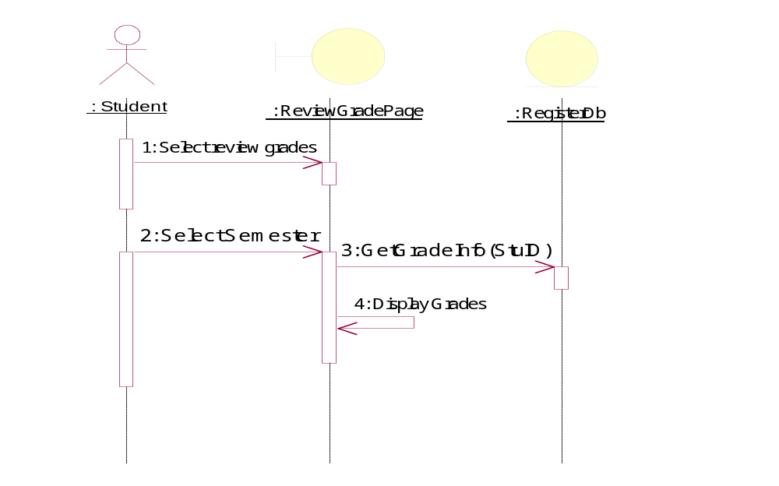

Sequence Diagram/Review grades

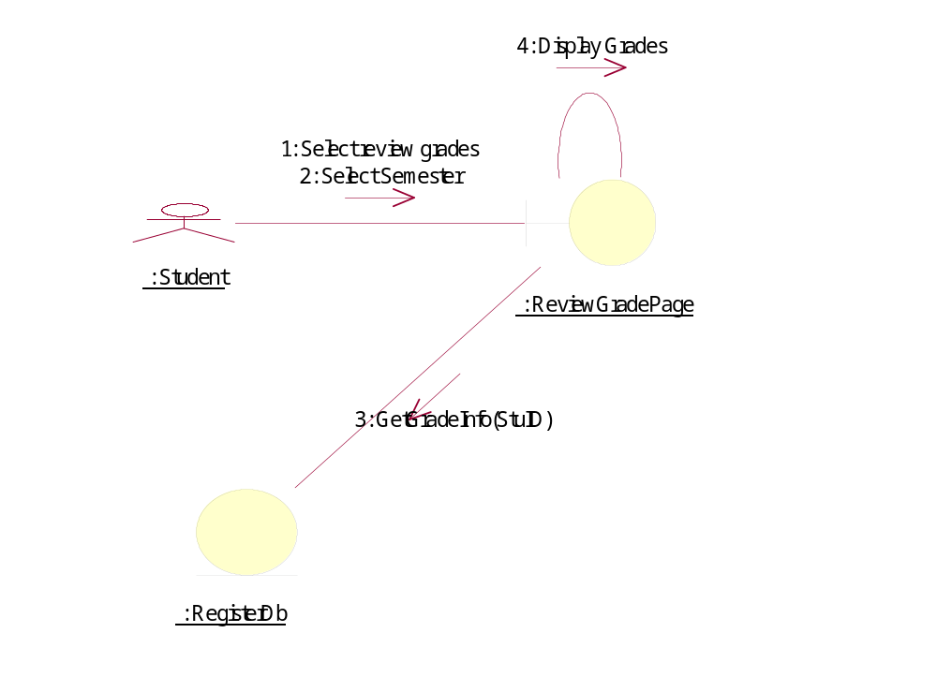

Collaboration Diagram/Review grades
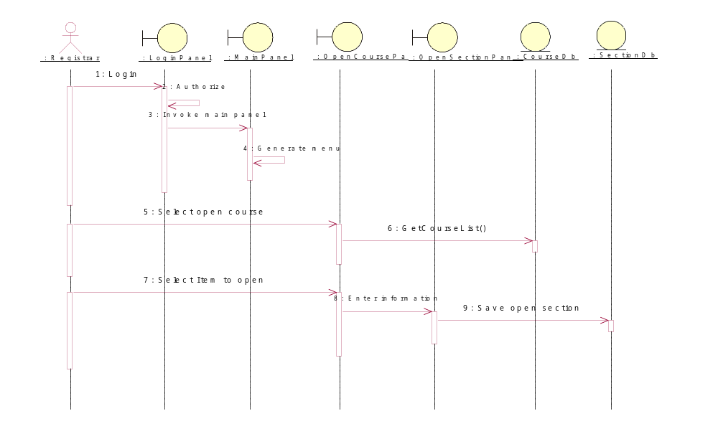

Sequence Diagram/Open course

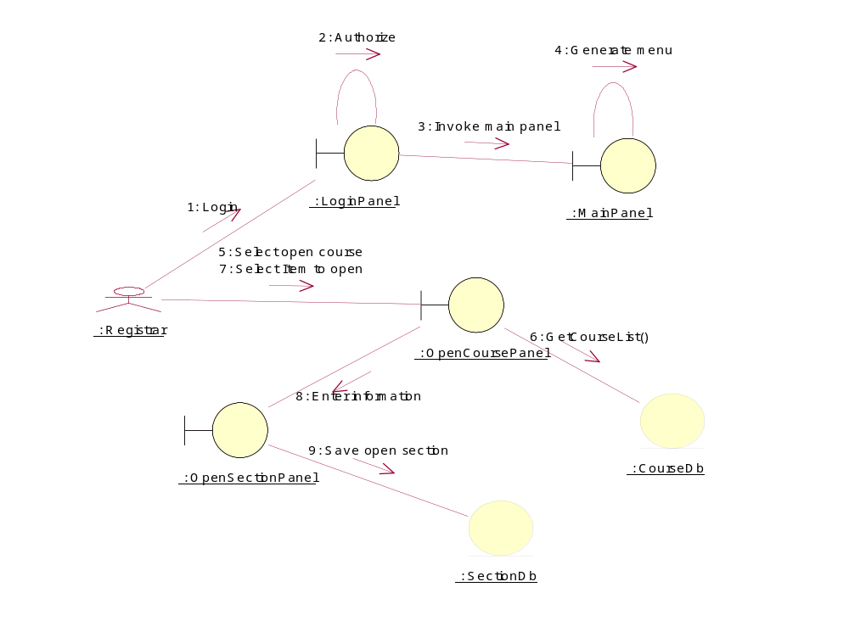

Collaboration Diagram/Open course
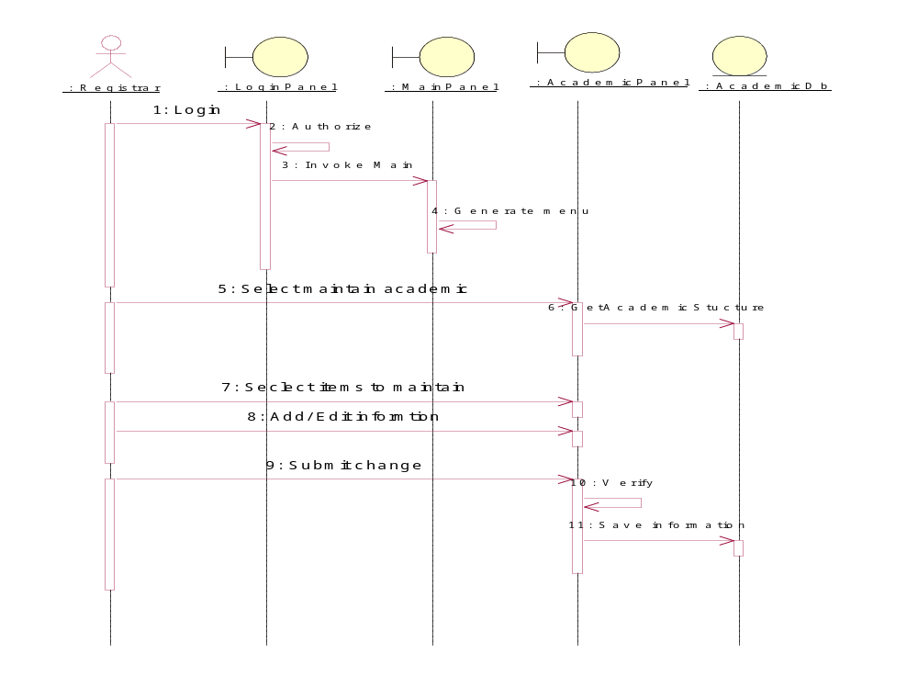

Sequence Diagram/Maintain academic information

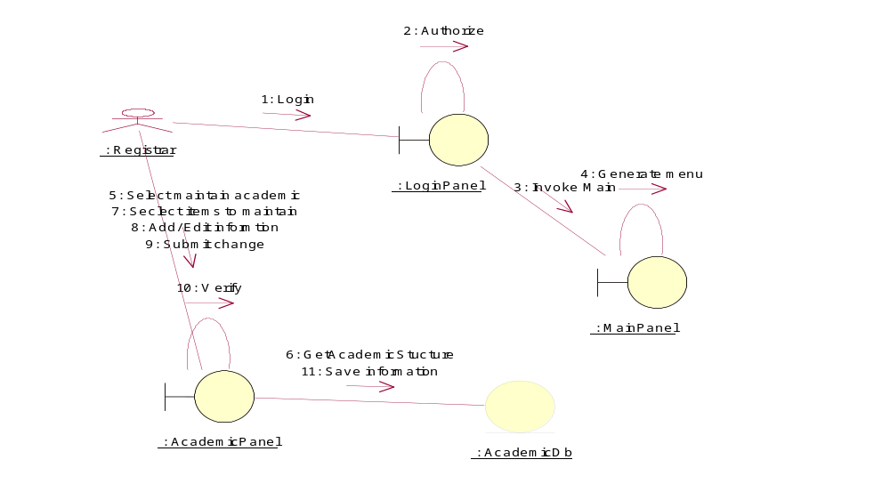

Collaboration Diagram/Maintain academic information
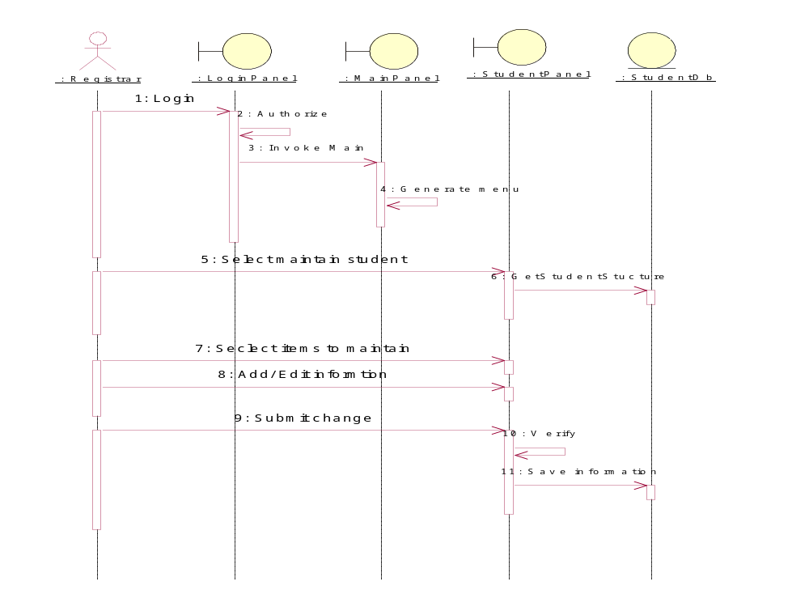

Sequence Diagram/Maintain student information

Collaboration Diagram/Maintain student information
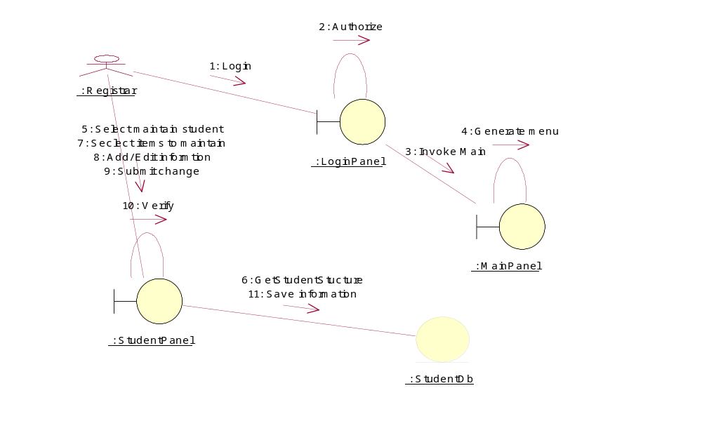
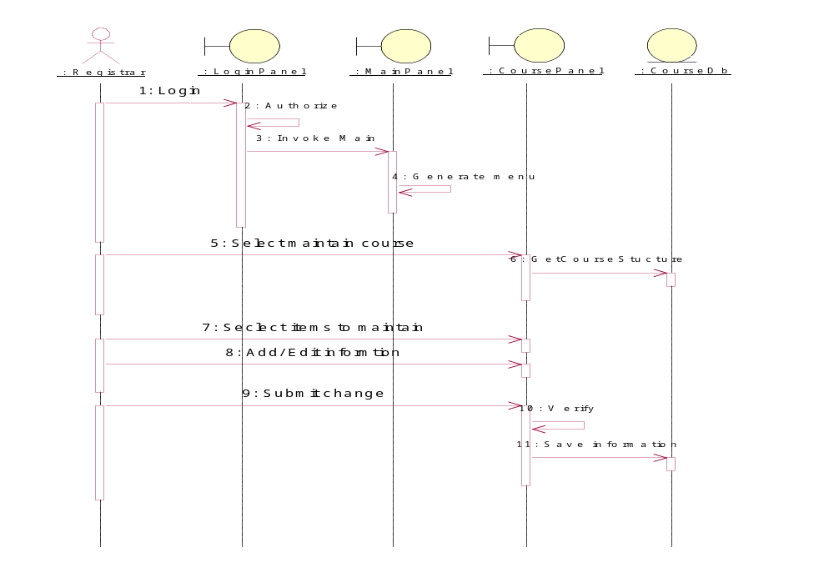

Sequence Diagram/Maintain course informations

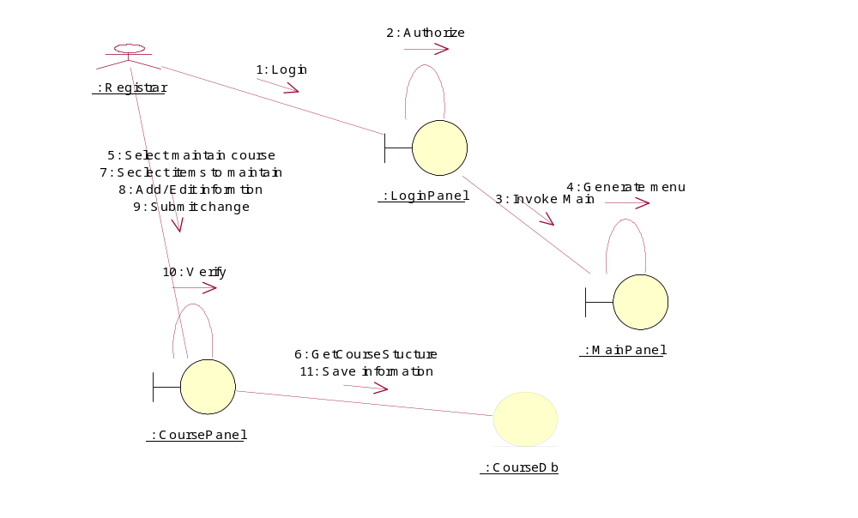

Collaboration Diagram/Maintain course informations

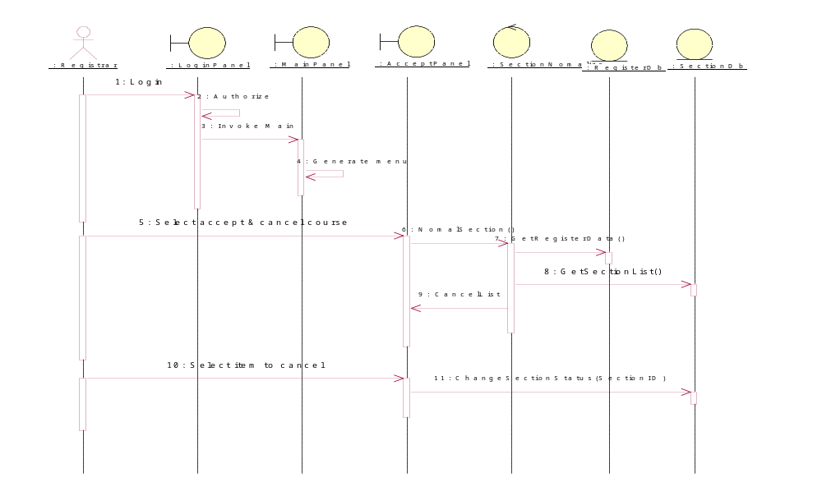

Sequence Diagram/Accept & cancel course

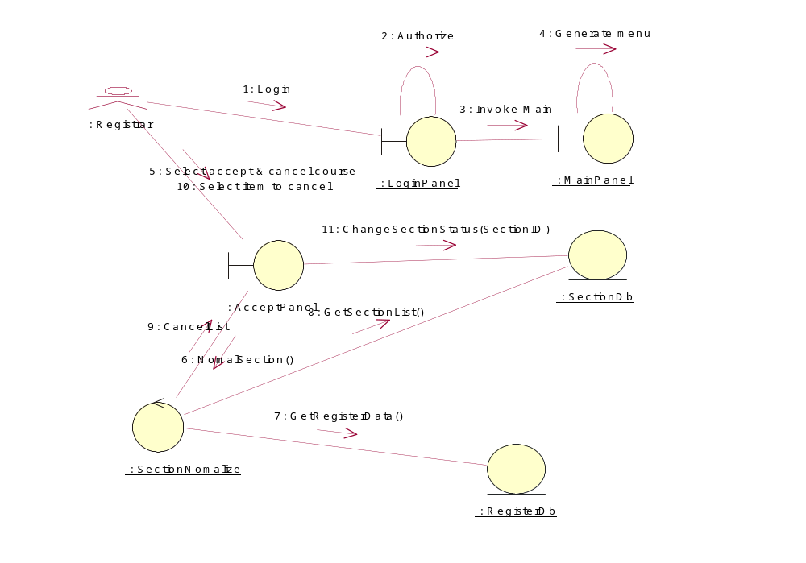

Collaboration Diagram/Accept & cancel course

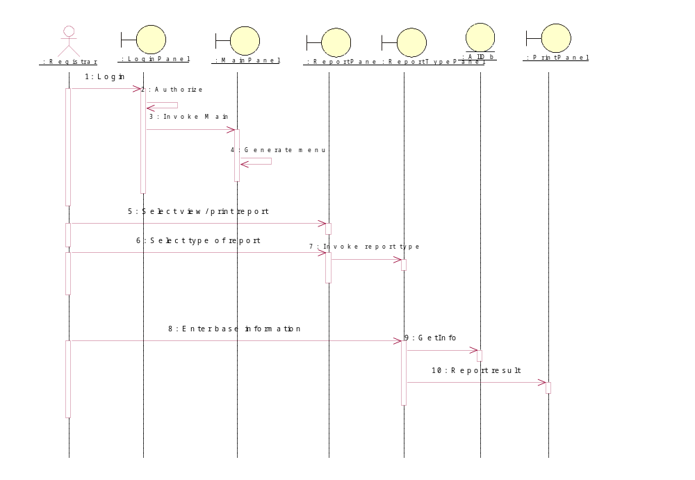

Sequence Diagram/View/Print report

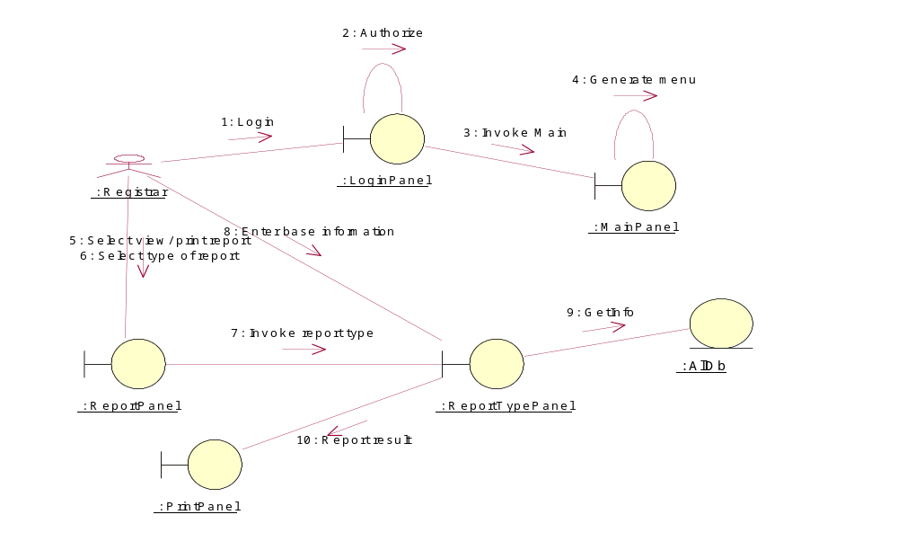

Collaboration Diagram/View/Print report
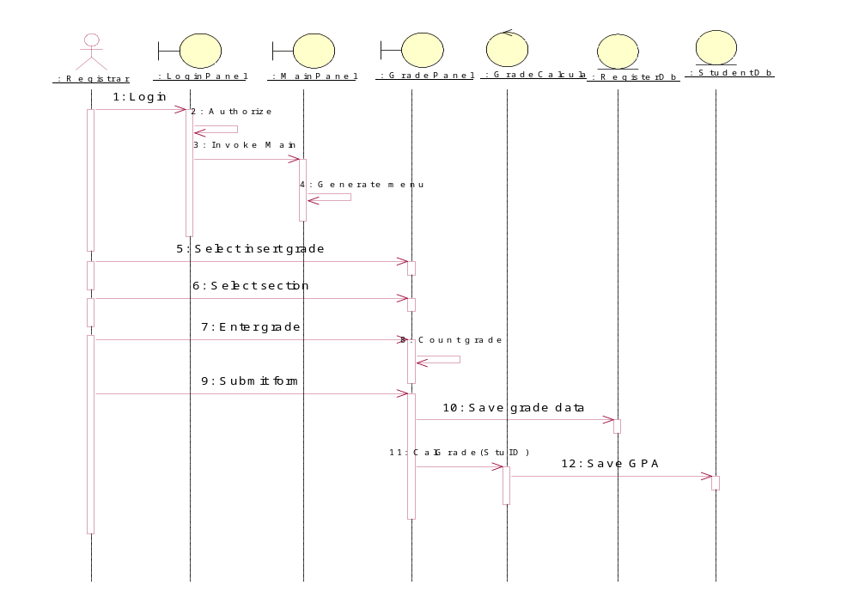
Sequence Diagram/Insert grades

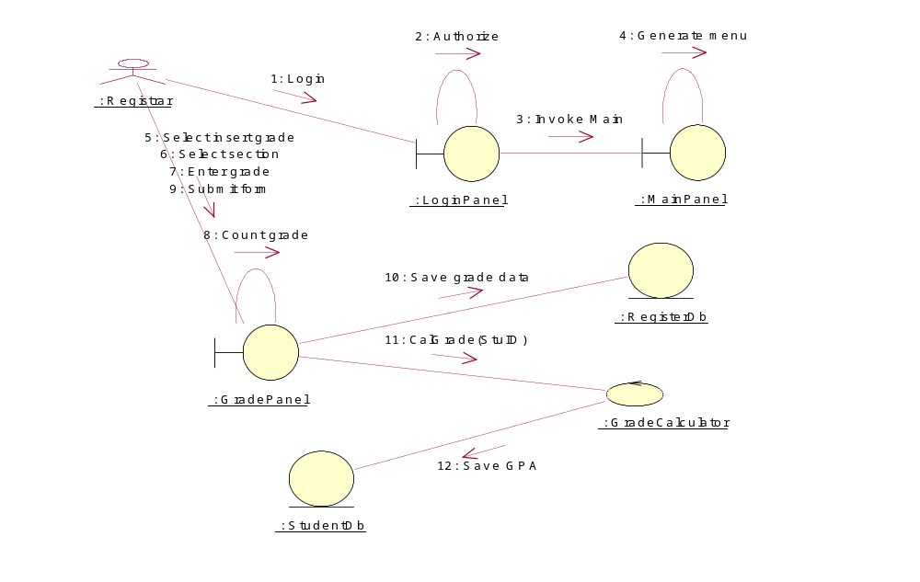

Collaboration Diagram/Insert grades

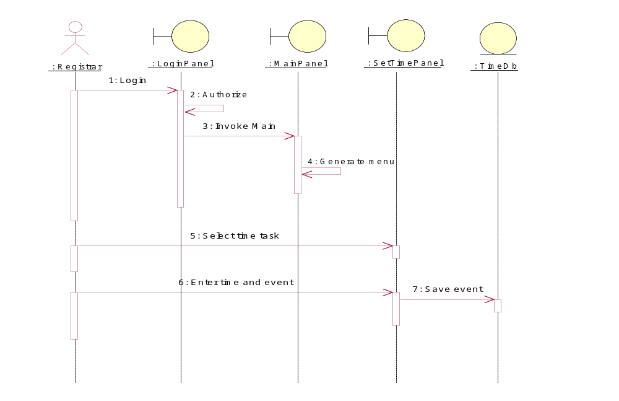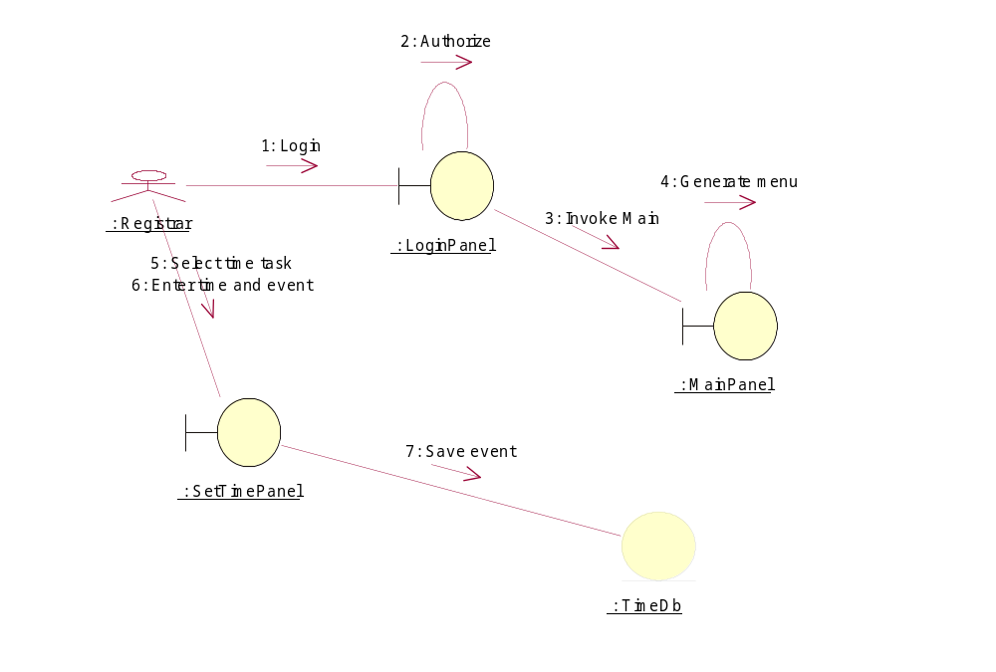

Sequence Diagram/Set time schedule

Collaboration Diagram/Set time schedule

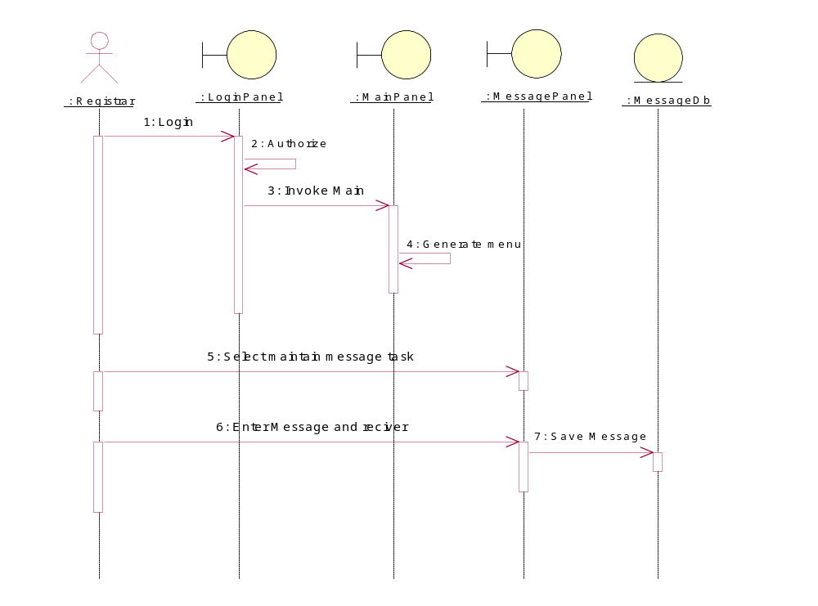
Sequence Diagram/Maintain message

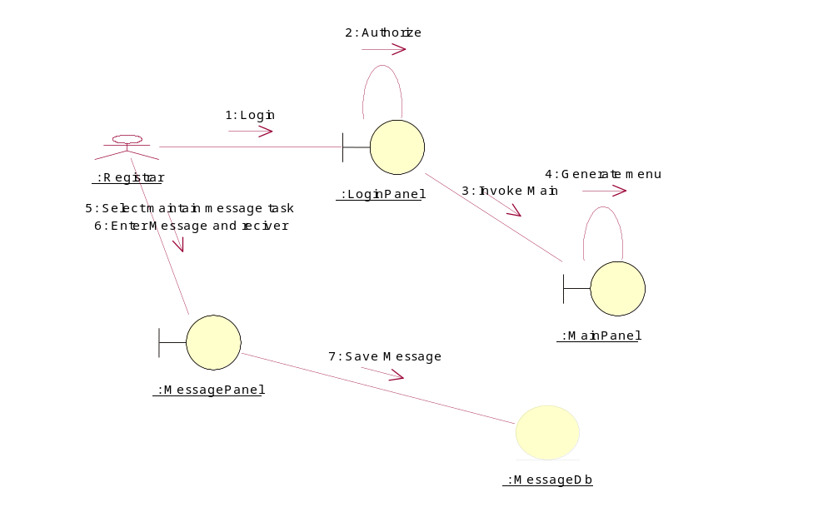

Collaboration Diagram/Maintain message

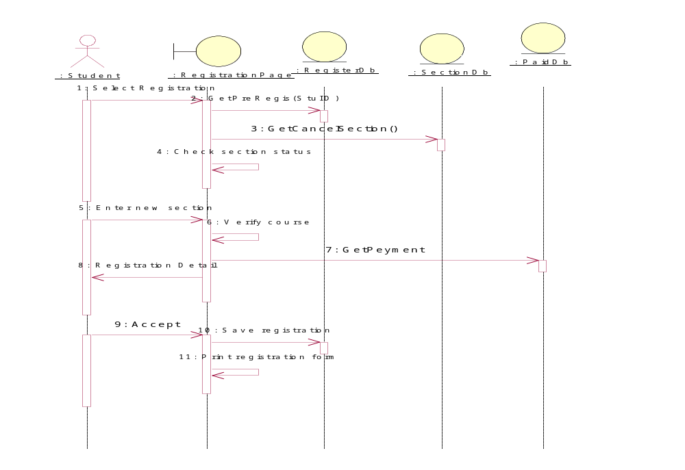
Sequence Diagram/Registration

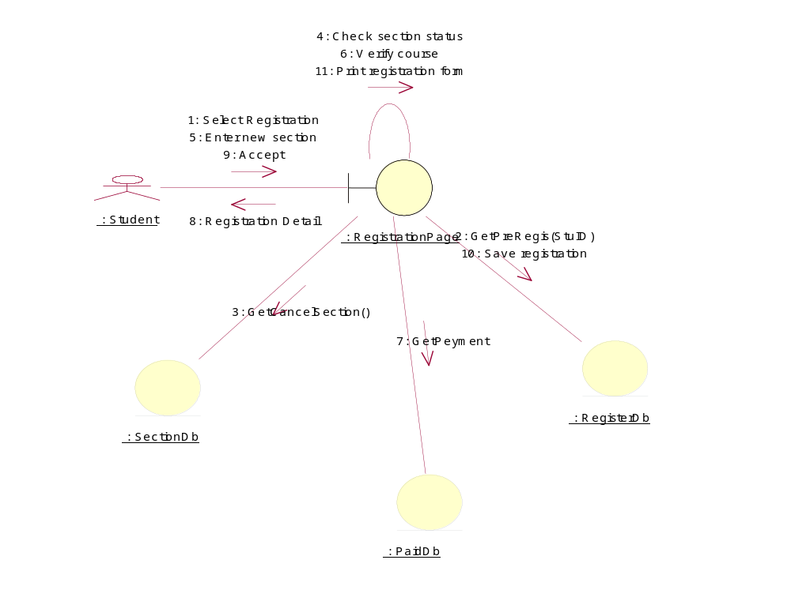

Collaboration Diagram/Registration
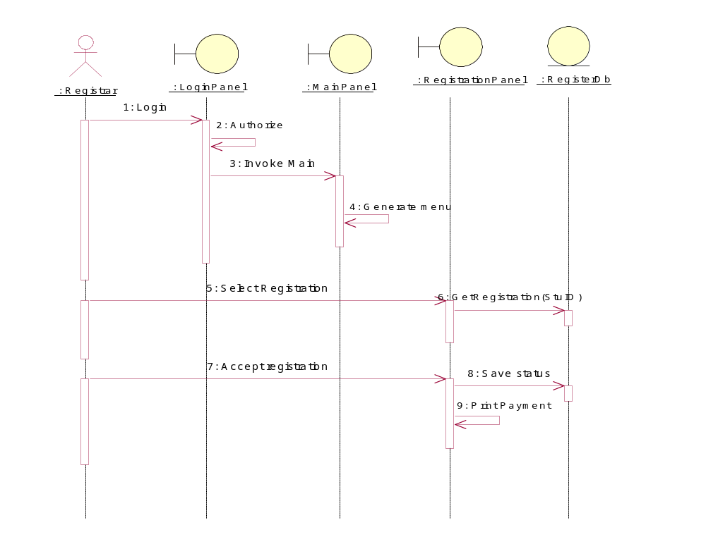

Sequence Diagram/AcceptRegistration
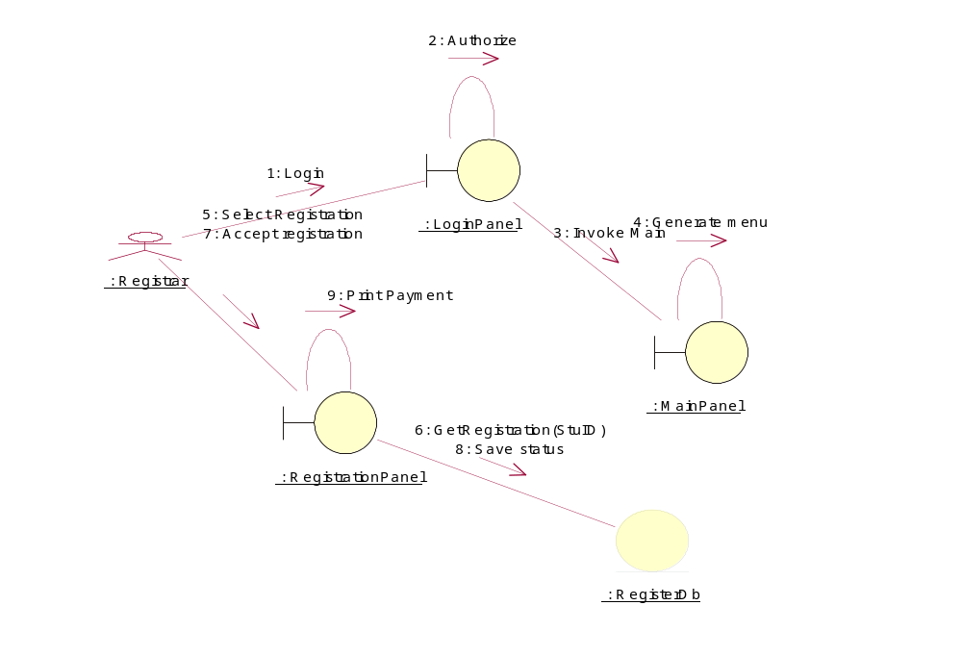

Collaboration Diagram/AcceptRegistration

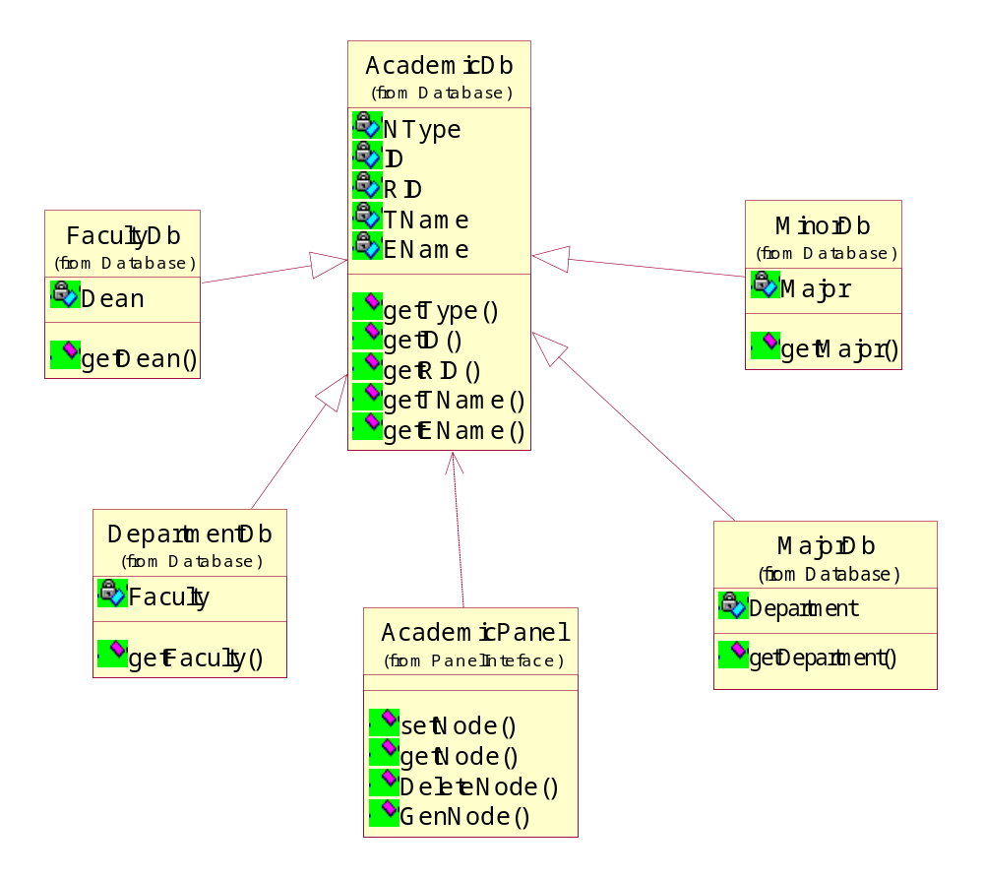

Class Diagram

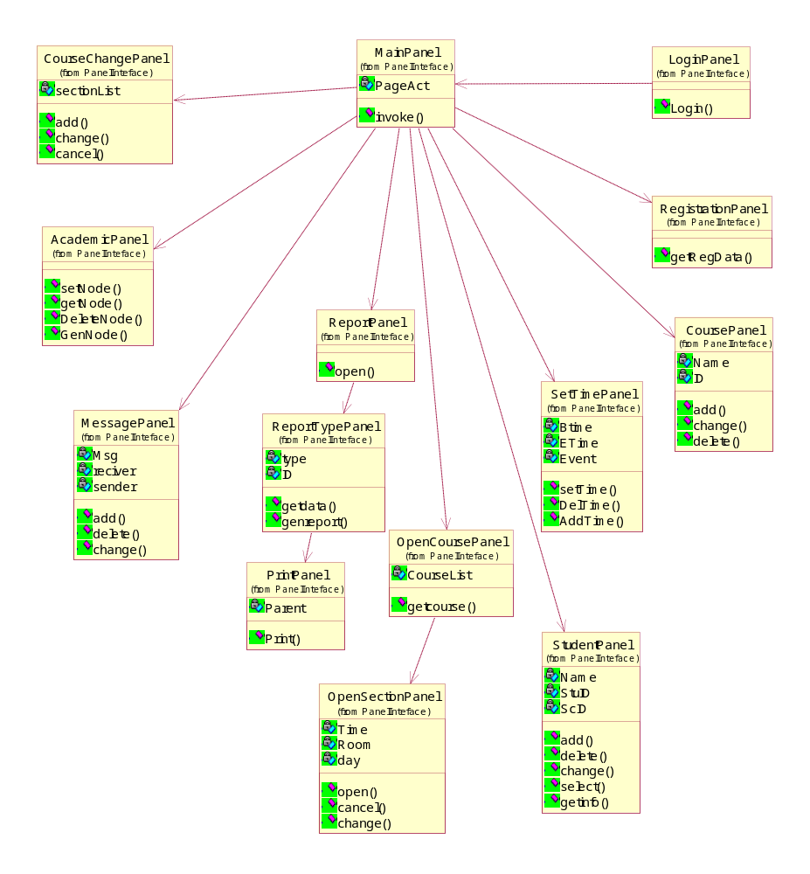

Class Diagram

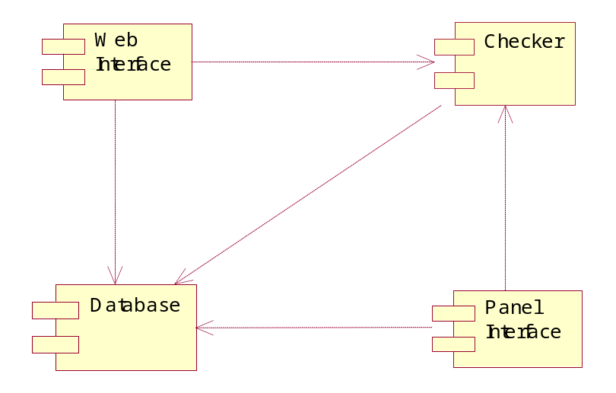

Component Diagram

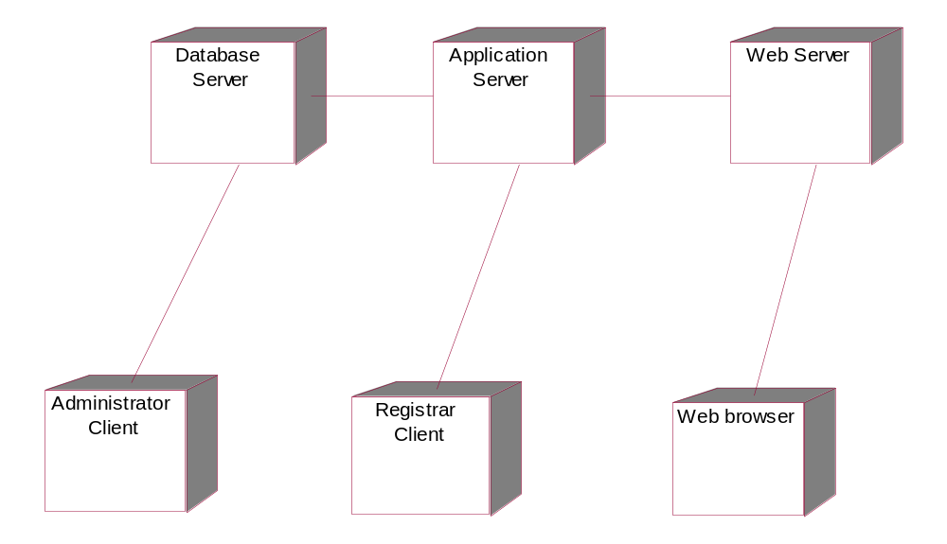

Deployment Diagram

